

Capstone Project Submission Form
These projects afford students an opportunity to apply their technical skill and knowledge of engineering principles to the development of a complex, team-oriented software project, system, or device. As they work on their capstone project, students have the opportunity to manage a project from beginning to end, learning how to deal with unexpected outcomes along the way. An excellent training ground for working in industry, the capstone project mirrors the type of experiences graduates will face when they begin their careers in engineering.
Company Name: Center for Cognitive Ubiquitous Computing (CUbiC)
Project title: Social Interaction Assistant

Name of the industry advisor: Dr. Sethuraman Panchanathan and PhD students Sreekar Krishna and CK.

Project description:
In the recent years, the importance of everyday social interactions has been identified as an important aspect of healthy living. Social interactions are so innate in the human living experience that the importance of the same has been overlooked. But individuals having some form of sensory or cognitive disabilities have identified the need to address the problems associated with the lack of information to carry out everyday social interactions. To this end, at CUbiC, we have been developing technologies for addressing social interaction problems and have built a first prototype of the same with three essential components: a) a camera mounted on the nose bridge of a pair of glasses, b) a Haptic Belt for information communication through touch, and c) Accelerometers for detecting head and body movements of individuals using the social interaction assistant. This capstone project is targeted at the combining the three independent components into a working prototype with all the elements interconnected.
The project will be focused on design of software modules that control the three components identified above. All development will be done on Windows OS with the aid of Visual Studio development environment in C++ and/or C#. The capstone team will be required to develop multithreaded application that will use one thread for each of the components explained above. Further, the team would integrate a Human Interface Device (HID) with 5 buttons as an input/control unit to the social interaction assistant.
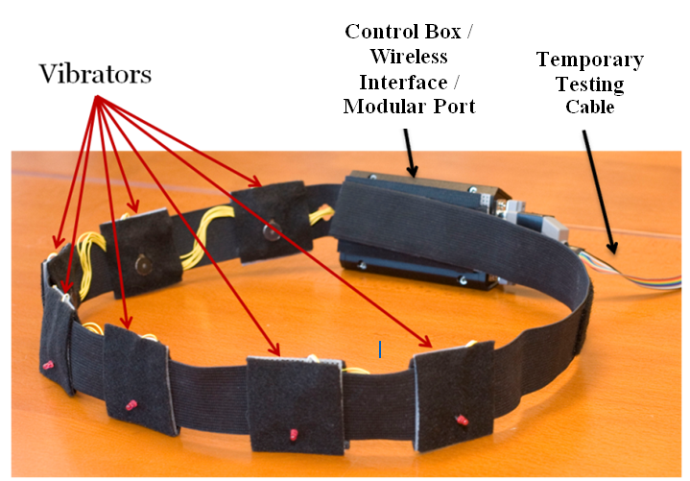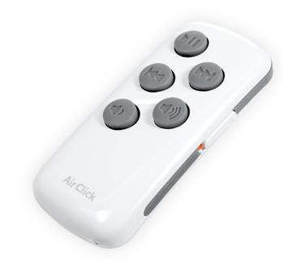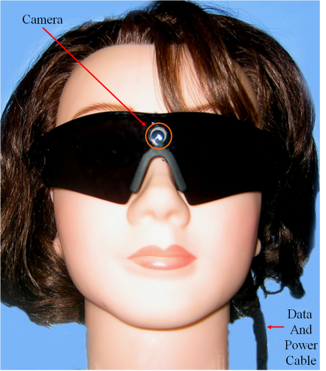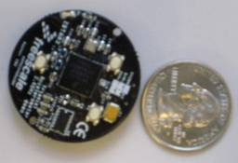
Figure: a) Camera on a pair of glasses. b) Haptic Belt. c) Accelerometer. d) Button HID input
(a)
(b)
(c)
(d)
A demonstration of the existing social interaction assistant and all its associated components (shown in the figure above (a,b,c)) will be done at the beginning of the semester.

Deliverables:
First semester: At the end of the first semester, the students would be required to develop the multithreaded functionality for controlling the various components of the device. Students will be working with various software toolkits including but not limited to DirectShow, VideoInput and Bluetooth communication stack. By the end of the semester the students would demonstrate the completely functional social interaction assistant with the 3 components integrated.
Second semester: At the end of the second semester, the students would be required to integrate a HID (shown in figure above (d)) with the social interaction assistant as input/control unit for the user. The students will conduct user studies on members of the CUbiC lab to determine any latency or thread interlocking issues so that the end device is capable of error free operations.

